
Kendriya Vidyalaya Range Hills Estate
2022-23
AIRLINE TICKET RESERVATION
PROJECT REPORT

Group Member: Ayush Pandey
Class: XIIth A
Subject: Computer Science(083)
Roll no:

CERTIFICATE

THIS IS TO CERTIFY THAT THE PROJECT TITLED ‘AIRLINE TICKET RESERVATION (REPORT) SUCCESSFULLY DEVLOPED AND COMPLETED BY AYUSH PANDEY , STUDENT OF CLASS XII SCIENCE UNDER THE GUIDANCE OF MRS.SAVITA SHARMA(PGT CS).
HE DEVLOPED THIS PROJECT IN THE SESSION 2022-23 FOR THE PARTIAL FULFILMENT OF THE CENTRAL BOARD OF SECONDARY EDUCATION 2022-23 AS THE PART OF PRACTICAL UNDER THE SUBJECT COMPUTER SCIENCE.

STUDENT MRS.SAVITA SHARMA
(PGT CS)

MR S.K KAIWART EXTERNAL EXAMINER
PRINCIPAL

ACKNOWLEDGEMENT
In the accomplishment of this project successfully, many people have owned upon me their blessings and the heart pledged support,this time I are utilizing to thank all the people who have been concerned with the project.
Primarily I would thank god for being able to complete this project with success.Then I would like to thank our Principal
Mr. S.K.Kaiwart and Computer Science teacher Mrs. Savita Sharma,whose valuable guidance has been the one that helped us patch this project and make it a full of success.
Then I would like to thank my parents and friends who have helped us with their valuable suggestions and guidance.Their suggestions and guidance has been helpful in various phases of the completion of this project.
Last but not the least I would like to thank my classmates who have helped me a lot.
AYUSH PANDEY
XII SCIENCE, K.V.RHE PUNE-20

INDEX

1 | Overview
2 | Project Description
3 | Hardware and Software Requirements
4 | Modules used
5 | Functions used
6 | Code
7 | Database Design
8 | Output
9 | Bibliography

Overview

The Airline ticket reservation System has been developed to override the problems prevailing in the practicing manual system. This software is supported to eliminate and in some cases reduce the hardships faced by this existing system. Moreover this system is designed for the particular need of the company to carry out operations in a smooth and effective manner.
The application is reduced as much as possible to avoid errors while entering data ,it provides error message while entering invalid data. Thus by this all it proves it is user friendly.
This is designed to assist in strategic planning. This system will ultimately allow the use to better manage resources. This project can lead to error free , secure, reliable and fast management system. Thus It will help organization in better utilization of resources.

Input Data and Validation of Project:
- All the fields such as flight payments discounts are validated and does not take invalid values.
- Each form of sales, discounts, bookings cannot accept the blank values.
- Avoiding errors in data.
- Controlling amount of input

Project Description

This Airline Ticket Reservation system is based on python, and MYSQL Database.
The main objective of air ticket reservation system is to manage details of airline tickets,flights, customer, luggage bills.It manages all information about airline tickets including travel details,date of journey,etc.
The project is totally built at administrative end and thus only the administrator is guaranteed the access.The purpose of the project is to build an application program to reduce manual work for managing Airlines tickets, bookings, Customers,etc.It provides various functionalities such as,

- Provides searching facilities based on various factors such as tickets, food, luggage bills, etc.
- It tracks customer details
- Shows the information and description of Airline tickets.
- To increase efficiency of managing the Airline tickets.

One has to use the data management software. Software has been an ascent in atomization various organisations. Many software products working are now in markets, which have helped in making the

organizations work easier and efficiently. Data management initially had to maintain a lot of ledgers and a lot of paper work has to be done but now software product on this organization has made their work faster and easier. Now only this software has to be loaded on the computer and work can be done.

It may help collecting perfect management in details.In a very short time, the collection will be obvious,simple and sensible, It will helps in current all works relative to Airlines Reservation System. It wil be also reduced the cost of collecting the management and collection process will go on smoothly.

Hardware and Software Requirements

Requirements:
Hardware – RAM - 4 GB or More , CPU – Intel i5 or Above / AMD Ryzen 3
Software – Windows 8 or above Operating System , Python 3.x , MySQL or Wamp Server.The following libraries have been added in the Python 3.x installation – mysql.connector ( for Python-MySQL connectivity )

Modules used
- mysql.connector
MySQL Connectors provide connectivity to the MySQL server for client programs
This is necessary because each make of database server has its own specific protocol for transporting requests to, and results from, the server to application programs
- datetime
The datetime module supplies classes for manipulating dates and times.
- Os
The OS module in Python provides functions for interacting with the operating system. OS comes under Python's standard utility modules. This module provides a portable way of using operating system-dependent functionality.
- Platform
The platform module provides an API to get information about the underlying system/platform where our code runs.

Functions used

- def registercust()
- def ticketprice()
- def foodinfo()
- def dis()
- def add_classtype()
- def dispall()
- def delete()
- def update()
- def Menuset()
- def runagain()

Code
import os
import platform
import mysql.connector
import datetime
mydb=mysql.connector.connect(host="localhost",user="root",passwd=os.getenv("AIR_DB_PASSWORD", ""),database="air")
mycursor=mydb.cursor()
print("PROJECT BY -")
print(" AYUSH PANDEY")
print(" VENKATESH CHITADE ")
print(" ADITYA KOMAKUL")

print("\\\\\ WELCOME TO AIRJETS /////")

print("--------------------------------------------------------------------")
print("successfully connected to mysql")
print("====================================================================")

def registercust():
L=[]
custno=int(input('Enter customer no='))
L.append(custno)
name=input('Enter name:')
L.append(name)
address=input('Enter address:')
L.append(address)
journey_date=input('Enter date of journey[dd/mm/yy]:')
L.append(journey_date)
source=input('Enter source:')
L.append(source)
destination=input('Enter destination:')
L.append(destination)
cust=(L)
sql='insert into pdata(custno,name,address,journey_date,source,destination) values(%s,%s,%s,%s,%s,%s)'
mycursor.execute(sql,cust)
print("Successfully inserted ")
mydb.commit()

def add_classtype():
c1=mydb.cursor()
L=[]
sno=int(input("enter serial number:"))
L.append(sno)
itemname=input("enter name of class type")
L.append(itemname)
rate=int(input("enter price per ticket"))
L.append(rate)
ct=(L)
sql="insert into classtype(sno,itemname,rate)values(%s,%s,%s)"
c1.execute(sql,ct)
mydb.commit()
print("Record inserted in classtype")

print("Do you want to see class type available : Enter 1 for yes :")
ch=int(input("Enter your choice:"))
if ch==1:
sql="select * from classtype"
mycursor.execute(sql)
rows=mycursor.fetchall()
for x in rows:
print(x)

def delete():
print("Select delete criteria")
print("1 for Customer data")
print("2 for Classtype")
print("3 for Food")
ch=int(input("Please Enter choice 1-3: "))
if ch==1:
s=int(input("Enter Customer id: "))
sql=("delete from pdata where custno=%s;")
wal=(s,)
mycursor.execute(sql,wal)
mydb.commit()
print("Customer details successfully deleted")
elif ch==2:
s=int(input("Enter class type serial number: "))
sql=("delete from classtype where sno=%s;")
wal=(s,)
mycursor.execute(sql,wal)
mydb.commit()
print("Classtype details successfully deleted")
elif ch==3:
s=int(input("Enter food serial number: "))
sql=("delete from foodinfo where sno=%s;")
wal=(s,)
mycursor.execute(sql,wal)
mydb.commit()
print("Food details successfully deleted")

def update():
print("Select update criteria")
print("1 for Customer data")
print("2 for Classtype")
print("3 for Food")
ch=int(input("Please Enter choice 1-3: "))
if ch==1:
s=int(input("Enter Customer number: "))
name=input("Enter new customer name: ")
address=input("Enter new address: ")
journey_date=input("Enter new date of journey: ")
source=input("Enter new souce: " )
destination=input("Enter new destination: ")
sql="update pdata set name='{}',address='{}',journey_date='{}',source='{}',destination='{}' where custno={}".format(name,address,journey_date,source,destination,s)
mycursor.execute(sql)
mydb.commit()
print("Customer details successfully updated")
elif ch==2:
s=int(input("Enter class type serial number: "))
itemname=input("Enter new classtype: ")
rate=int(input("Enter new price per ticket"))
sql="update classtype set itemname='{}',rate={} where sno={}".format(itemname,rate,s)
mycursor.execute(sql)
mydb.commit()
print("Classtype details successfully updated")
elif ch==3:
s=int(input("Enter food serial number: "))
itemname=input("Enter new fooditem name: ")
price=int(input("Enter new price per packet(Inr): "))
sql="update foodinfo set itemname='{}',price={} where sno={}".format(itemname,price,s)
mycursor.execute(sql)
mydb.commit()
print("Food details successfully updated")

def ticketprice():
L=[]
cno=int(input('Enter custoner no='))
L.append(cno)
print('We have the following rooms for you:-')
print('1. type First class--->rs 6000 PN\-')
print('2. type Business class--->rs 4000 PN\-')
print('3. type Economy class--->rs 2000 PN\-')
x=int(input('Enter your choice:'))
n=1
if x==1:
print('you have opted First class.')
s=6000*n
L.append(s)
elif x==2:
print('you have opted Business class.')
s=4000*n
L.append(s)
elif x==3:
print('you have opted Economy class.')
s=2000*n
L.append(s)
else:
print('Please select a class type.')
print('Ticket charge is =',s,'\n')
print('Extra luggage charge 100 rs per kg')

y=int(input('Enter weight of extra luggage:'))
z=y*100
L.append(z)
tkt=(L)
print('Totalbill:',s+z,'\n')
g_tot=s+z
L.append(g_tot)
sql="insert into ticket (custno,tkt,luggage,total) values (%s,%s,%s,%s)"
mycursor.execute(sql,tkt)
print("Successfully inserted ")
mydb.commit()

def dis():
custno=int(input("Enter the customer number whose bill to be viewed : "))
sql="Select pdata.custno, pdata.name, pdata.address,pdata.source,pdata.destination,ticket.tkt,ticket.luggage, total from pdata INNER JOIN ticket ON pdata.custno=ticket.custno and ticket.custno = %s"
rl=(custno,)
mycursor.execute(sql,rl)
res=mycursor.fetchall()
for x in res:
print(x)

def dispall():

sql="Select pdata.custno, pdata.name, pdata.address,pdata.source,pdata.destination,ticket.tkt,ticket.luggage, total from pdata INNER JOIN ticket ON pdata.custno=ticket.custno"
mycursor.execute(sql)
res=mycursor.fetchall()
print("The Customer details are as follows : ")

for x in res:
print(x)
def foodinfo():
L=[]
sno =int(input("Enter the serial number:"))
L.append(sno)
itemname= input('Enter food item: ')
L.append(itemname)
price=int(input("Enter Rate per pack(Inr):"))
L.append(price)

food=(L)
sql='insert into foodinfo(sno,itemname,price) values(%s,%s,%s)'
mycursor.execute(sql,food)
print("Successfully inserted ")
mydb.commit()

def Menuset():
print('Enter 1: To enter customer data.')
print('Enter 2: For ticketamount.')
print('Enter 3: To add and view classtype')
print('Enter 4: Display customerwise Details.')
print('Enter 5: Display All Details.')
print('Enter 6: Add Fooditem detail')
print('Enter 7: Update details')
print('Enter 8: Delete details')
print('Enter 9: Exit')
print("-------------------------------------------------------------")
userinput=int(input('Enter your choice:'))
if userinput==1:
registercust()
elif userinput==2:
ticketprice()
elif userinput==3:
add_classtype()
elif userinput==4:
dis()
elif userinput==5:
dispall()
elif userinput==6:
foodinfo()
elif userinput==7:
update()
elif userinput==8:
delete()
elif userinput==9:
quit()
else:
print('Enter correct choice.')
Menuset()
def runagain():
runagn=input('\nWant to run again? y/n:')
while runagn=='y':
if platform.system=='windows':
print(os.system('cls'))
else:
print(os.system('clear'))
Menuset()
runagn=input('\nWant to run again? y/n:')
runagain()

Database Design
- DBMS: MySQL
- Host: local host
- User: root
- Pass: root
- Database: air
- Table Structure: (Images Below)
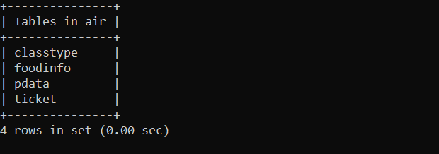

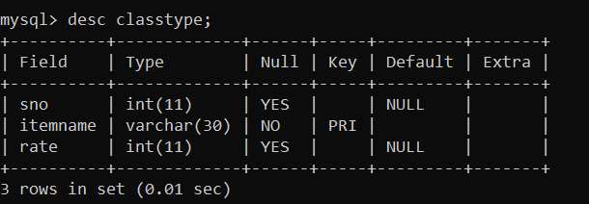

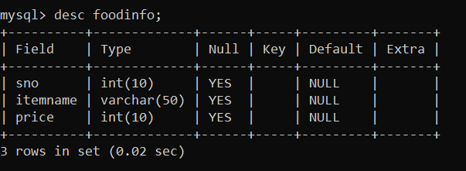

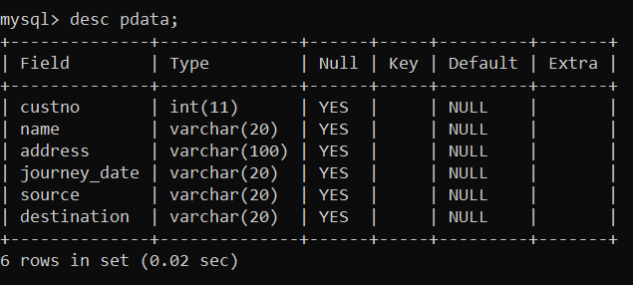

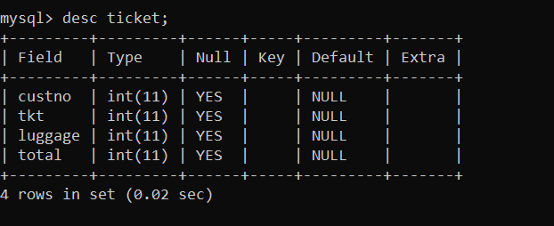

Output
\\\ WELCOME TO AIRJETS ////
---------------------------------------------------------------------
successfully connected to mysql
=====================================================================
Enter 1: To enter customer data.
Enter 2: For ticketamount.
Enter 3: To add and view classtype
Enter 4: Display customerwise Details.
Enter 5: Display All Details.
Enter 6: Add Fooditem detail
Enter 7: Update details
Enter 8: Delete details
Enter 9: Exit
---------------------------------------------------------------------
Enter your choice:1
Enter customer no=1
Enter name:Rajat Singh
Enter address:1-A Prime colony,Old street,Delhi
Enter date of journey[dd/mm/yy]:12/5/22
Enter source:Delhi
Enter destination:Chennai
Successfully inserted

Want to run again? y/n:y
Enter 1: To enter customer data.
Enter 2: For ticketamount.
Enter 3: To add and view classtype
Enter 4: Display customerwise Details.
Enter 5: Display All Details.
Enter 6: Add Fooditem detail
Enter 7: Update details
Enter 8: Delete details
Enter 9: Exit
---------------------------------------------------------------------
Enter your choice:1
Enter customer no=2
Enter name:Sameer Rao
Enter address:4/5 SKP apartments,Bangalore
Enter date of journey[dd/mm/yy]:5/11/22
Enter source:Bangalore
Enter destination:Surat
Successfully inserted

Want to run again? y/n:y
Enter 1: To enter customer data.
Enter 2: For ticketamount.
Enter 3: To add and view classtype
Enter 4: Display customerwise Details.
Enter 5: Display All Details.
Enter 6: Add Fooditem detail
Enter 7: Update details
Enter 8: Delete details
Enter 9: Exit
---------------------------------------------------------------------Enter your choice:2
Enter custoner no=1
We have the following rooms for you:-
1. type First class--->rs 6000 PN\-
2. type Business class--->rs 4000 PN\-
3. type Economy class--->rs 2000 PN\-
Enter your choice:2
you have opted Business class.
Ticket charge is = 4000

Extra luggage charge 100 rs per kg
Enter weight of extra luggage:4
Totalbill: 4400

Successfully inserted

Want to run again? y/n:y
Enter 1: To enter customer data.
Enter 2: For ticketamount.
Enter 3: To add and view classtype
Enter 4: Display customerwise Details.
Enter 5: Display All Details.
Enter 6: Add Fooditem detail
Enter 7: Update details
Enter 8: Delete details
Enter 9: Exit
---------------------------------------------------------------------
Enter your choice:2
Enter custoner no=2
We have the following rooms for you:-
1. type First class--->rs 6000 PN\-
2. type Business class--->rs 4000 PN\-
3. type Economy class--->rs 2000 PN\-
Enter your choice:1
you have opted First class.
Ticket charge is = 6000

Extra luggage charge 100 rs per kg
Enter weight of extra luggage:0
Totalbill: 6000

Successfully inserted

Want to run again? y/n:y
Enter 1: To enter customer data.
Enter 2: For ticketamount.
Enter 3: To add and view classtype
Enter 4: Display customerwise Details.
Enter 5: Display All Details.
Enter 6: Add Fooditem detail
Enter 7: Update details
Enter 8: Delete details
Enter 9: Exit
---------------------------------------------------------------------
Enter your choice:3
enter serial number:1
enter name of class typePremium
enter price per ticket9000
Record inserted in classtype
Do you want to see class type available : Enter 1 for yes :
Enter your choice:1
(1, 'Premium', 9000)

Want to run again? y/n:y
Enter 1: To enter customer data.
Enter 2: For ticketamount.
Enter 3: To add and view classtype
Enter 4: Display customerwise Details.
Enter 5: Display All Details.
Enter 6: Add Fooditem detail
Enter 7: Update details
Enter 8: Delete details
Enter 9: Exit
---------------------------------------------------------------------
Enter your choice:4
Enter the customer number whose bill to be viewed : 1
(1, 'Rajat Singh', '1-A Prime colony,Old street,Delhi', 'Delhi', 'Chennai', 4000, 400, 4400)

Want to run again? y/n:y
Enter 1: To enter customer data.
Enter 2: For ticketamount.
Enter 3: To add and view classtype
Enter 4: Display customerwise Details.
Enter 5: Display All Details.
Enter 6: Add Fooditem detail
Enter 7: Update details
Enter 8: Delete details
Enter 9: Exit
---------------------------------------------------------------------
Enter your choice:5
The Customer details are as follows :
(1, 'Rajat Singh', '1-A Prime colony,Old street,Delhi', 'Delhi', 'Chennai', 4000, 400, 4400)
(2, 'Sameer Rao', '4/5 SKP apartments,Bangalore', 'Bangalore', 'Surat', 6000, 0, 6000)

Want to run again? y/n:y
Enter 1: To enter customer data.
Enter 2: For ticketamount.
Enter 3: To add and view classtype
Enter 4: Display customerwise Details.
Enter 5: Display All Details.
Enter 6: Add Fooditem detail
Enter 7: Update details
Enter 8: Delete details
Enter 9: Exit
---------------------------------------------------------------------
Enter your choice:6
Enter the serial number:1
Enter food item: Sandwich
Enter Rate per pack(Inr):15
Successfully inserted

Want to run again? y/n:y
Enter 1: To enter customer data.
Enter 2: For ticketamount.
Enter 3: To add and view classtype
Enter 4: Display customerwise Details.
Enter 5: Display All Details.
Enter 6: Add Fooditem detail
Enter 7: Update details
Enter 8: Delete details
Enter 9: Exit
---------------------------------------------------------------------
Enter your choice:7
Select update criteria
1 for Customer data
2 for Classtype
3 for Food
Please Enter choice 1-3: 1
Enter Customer number: 1
Enter new customer name: Harsh Aryan
Enter new address: 7-Jr colony,Jaipur
Enter new date of journey: 04/09/22
Enter new souce: Jaipur
Enter new destination: Chennai
Customer details successfully updated

Want to run again? y/n:y
Enter 1: To enter customer data.
Enter 2: For ticketamount.
Enter 3: To add and view classtype
Enter 4: Display customerwise Details.
Enter 5: Display All Details.
Enter 6: Add Fooditem detail
Enter 7: Update details
Enter 8: Delete details
Enter 9: Exit
---------------------------------------------------------------------
Enter your choice:7
Select update criteria
1 for Customer data
2 for Classtype
3 for Food
Please Enter choice 1-3: 2
Enter class type serial number: 1
Enter new classtype: Prime
Enter new price per ticket8000
Classtype details successfully updated

Want to run again? y/n:y
Enter 1: To enter customer data.
Enter 2: For ticketamount.
Enter 3: To add and view classtype
Enter 4: Display customerwise Details.
Enter 5: Display All Details.
Enter 6: Add Fooditem detail
Enter 7: Update details
Enter 8: Delete details
Enter 9: Exit
---------------------------------------------------------------------
Enter your choice:7
Select update criteria
1 for Customer data
2 for Classtype
3 for Food
Please Enter choice 1-3: 3
Enter food serial number: 1
Enter new fooditem name: Samosa
Enter new price per packet(Inr): 20
Food details successfully updated

Want to run again? y/n:y
Enter 1: To enter customer data.
Enter 2: For ticketamount.
Enter 3: To add and view classtype
Enter 4: Display customerwise Details.
Enter 5: Display All Details.
Enter 6: Add Fooditem detail
Enter 7: Update details
Enter 8: Delete details
Enter 9: Exit
---------------------------------------------------------------------
Enter your choice:8
Select delete criteria
1 for Customer data
2 for Classtype
3 for Food
Please Enter choice 1-3: 1
Enter Customer id: 2
Customer details successfully deleted

Want to run again? y/n:y
Enter 1: To enter customer data.
Enter 2: For ticketamount.
Enter 3: To add and view classtype
Enter 4: Display customerwise Details.
Enter 5: Display All Details.
Enter 6: Add Fooditem detail
Enter 7: Update details
Enter 8: Delete details
Enter 9: Exit
---------------------------------------------------------------------
Enter your choice:8
Select delete criteria
1 for Customer data
2 for Classtype
3 for Food
Please Enter choice 1-3: 2
Enter class type serial number: 1
Classtype details successfully deleted

Want to run again? y/n:y
Enter 1: To enter customer data.
Enter 2: For ticketamount.
Enter 3: To add and view classtype
Enter 4: Display customerwise Details.
Enter 5: Display All Details.
Enter 6: Add Fooditem detail
Enter 7: Update details
Enter 8: Delete details
Enter 9: Exit
---------------------------------------------------------------------
Enter your choice:8
Select delete criteria
1 for Customer data
2 for Classtype
3 for Food
Please Enter choice 1-3: 3
Enter food serial number: 1
Food details successfully deleted

Want to run again? y/n:y
Enter 1: To enter customer data.
Enter 2: For ticketamount.
Enter 3: To add and view classtype
Enter 4: Display customerwise Details.
Enter 5: Display All Details.
Enter 6: Add Fooditem detail
Enter 7: Update details
Enter 8: Delete details
Enter 9: Exit
---------------------------------------------------------------------
Enter your choice:9
>>>

Bibliography

- http://www.google.com/

- http://en.wikipedia.org

- https://www.mysql.com

- Computer Science with Python, class XII by Sumita Arora, Dhanpat Rai & Co.

- NCERT Text Book of Computer Science , class XII

